**Project Report Phase- 2**

Top of Form

Bottom of Form

Created by- PRANAV UPPAL

Software Requirements Specification Operating System:

* **Windows**
* **Database: Firebase**
* **Tools: Android studio**
* **Technologies Used: Java**
* **Network: Internet Connectivity Required**.

Objectives:

The basic objective of this project is to develop an android-based system with following features, namely:

1. **Questions bank**
2. **Time frame**
3. **Life lines**
4. **Data Storage**
5. **Multimedia support (pictures, snapshots, tables).**

The main objective to create this Quiz app is to help the users for the preparation of necessary educational purposes regarding Computer Science and IT field with an easy access to our app directly on their Android phones. Through our app, users can learn and prepare themselves for interviews, tests and exams on Android phones, and can also use this app for increasing their general knowledge about Computer Science, Verbal and Analytical everywhere and anytime.

Hardware Requirements( Specification For Mobile Device):

* RAM: 256 MB
* Disk Space: 250 MB

For Developer to develop, test the project:

* Processor: Intel Pentium IV or higher
* RAM: 4 GB or higher.
* Hard Disk: 160 GB or higher.

Android Application Framework

The Android applications directly interact with the Android Framework to run and are managed here. Resource Management, Voice call management and activities like these are handled by the application framework.

The Android framework includes the following key services:

* Activity Manager – The activity stack and the application lifecycle are controlled by activity manager.
* Content Providers – The data is shared and published with other applications using this content providers.
* Resource Manager – The non-code embedded resources such as strings, color settings and user interface layouts are accessed using this resource manager.
* Notifications Manager – The display alerts and notifications to the user are given by this notifications manager.
* View System –The user interfaces of the application are created by using this view system.
* Package Manager – The other applications which are in the current device knows information about the other applications that are in the device using this package manager.
* Telephony Manager – The information such as status and subscriber is provided to the application using the telephony manager.
* Location Manager – The changes in the location and the updating of the location is done by this location manager.

System Architecture:

System Architecture Diagram

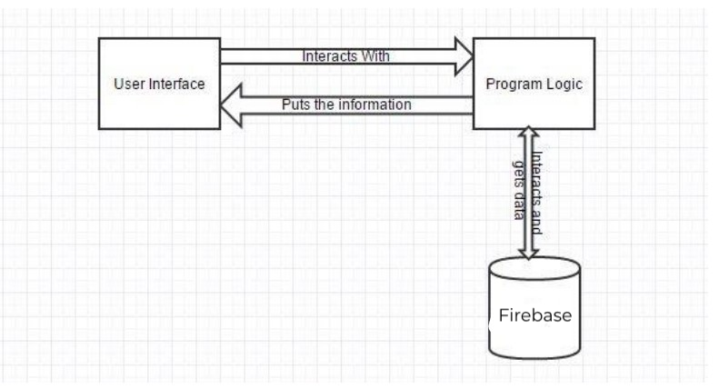

The above architecture diagram clearly shows the architecture of the Project. Using the User Interface the user of the application interacts with the programmed business logic. The business gets the data from the database which is Firebase in this application. This Interacts and gives the data to the programmed logic and the information is processed and displayed back on the user interface.

Use Case Diagram:

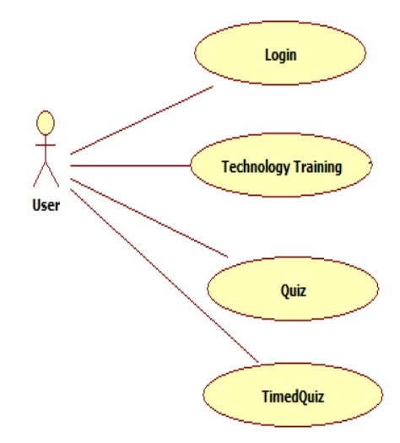

The User of the application interacts with the application interacts with the application. Then he can select one out of three options i.e. Technology Training, Quiz and Timed Quiz. User can also select Quiz, attend the quiz and he/she can retake the quiz on a different technology. User can also select timed quiz and he/she can take the quiz on the technology he/she likes.

Class Diagram:

The user of the application logins and registers with a username and using the Register( ) and Login( ) methods. After logging into the application the user has three options now. The user can take training or take quiz or timed quiz or take three one after the other.

The user selects the Training he/she is interested in. User can do that using the methods which selects one language out of different technologies that are available and user can take training( ), the functionality is defines in this method. If the user selects Timed Quiz and user can play the timed quiz using the play timed quiz( ) method and he can view the results using the show result( ).

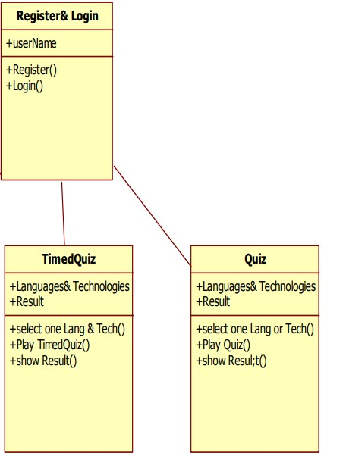

App Manifest:

The essential information like Functionality and requirements of your android application are described in the app manifest file. The package name which serves as a unique identifier for the application is named by the app manifest. The host application component processes 18 are determined by the app manifest. The permission to interact with the applications are declared in the app manifest. This app manifest has the minimum API level that is required to host the application, permissions to access protected parts of that API and it also has the list of libraries that are to be linked. The activities, services, broadcast receivers, and content providers that the application is composed of are described in the app manifest this allows the application to know which screen is to be launched first.

- Implementation

Screens:

Start Page:

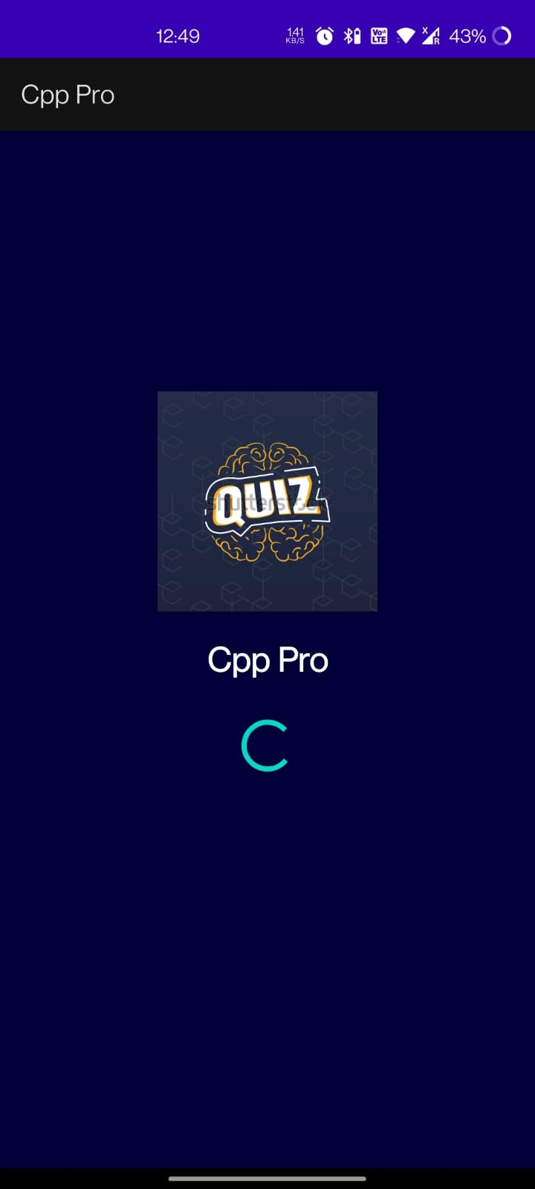

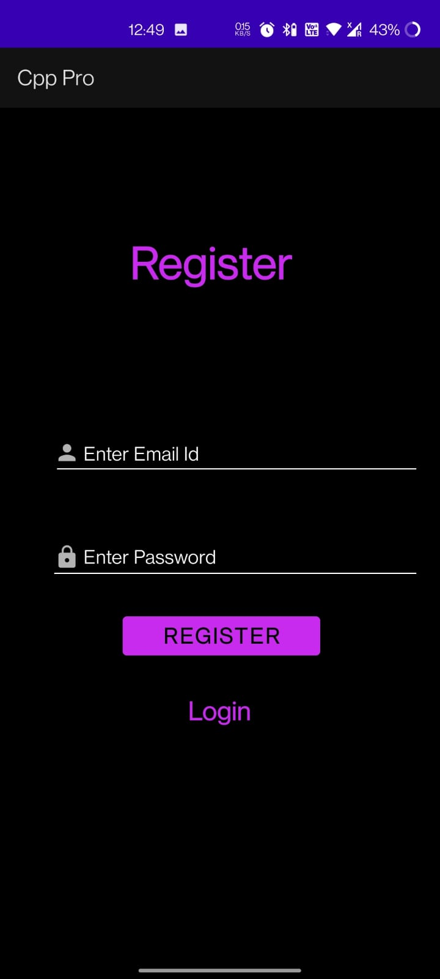

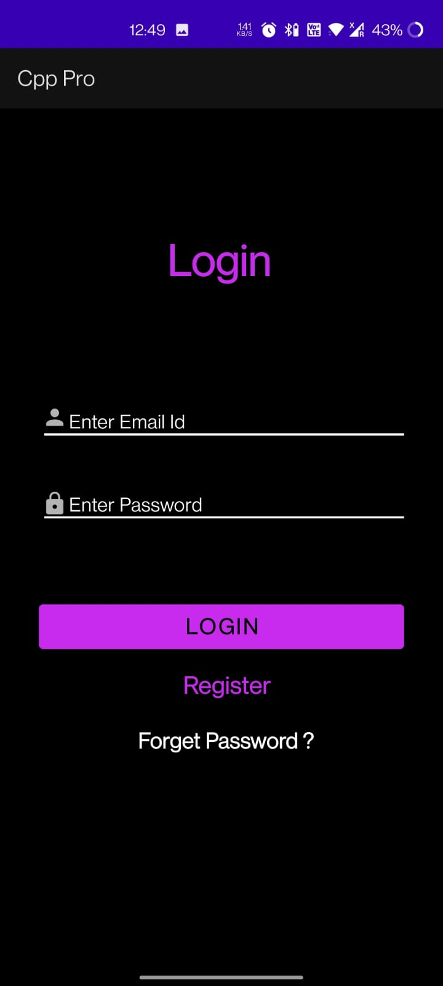Top of Form

Bottom of Form